Layout of the GUI

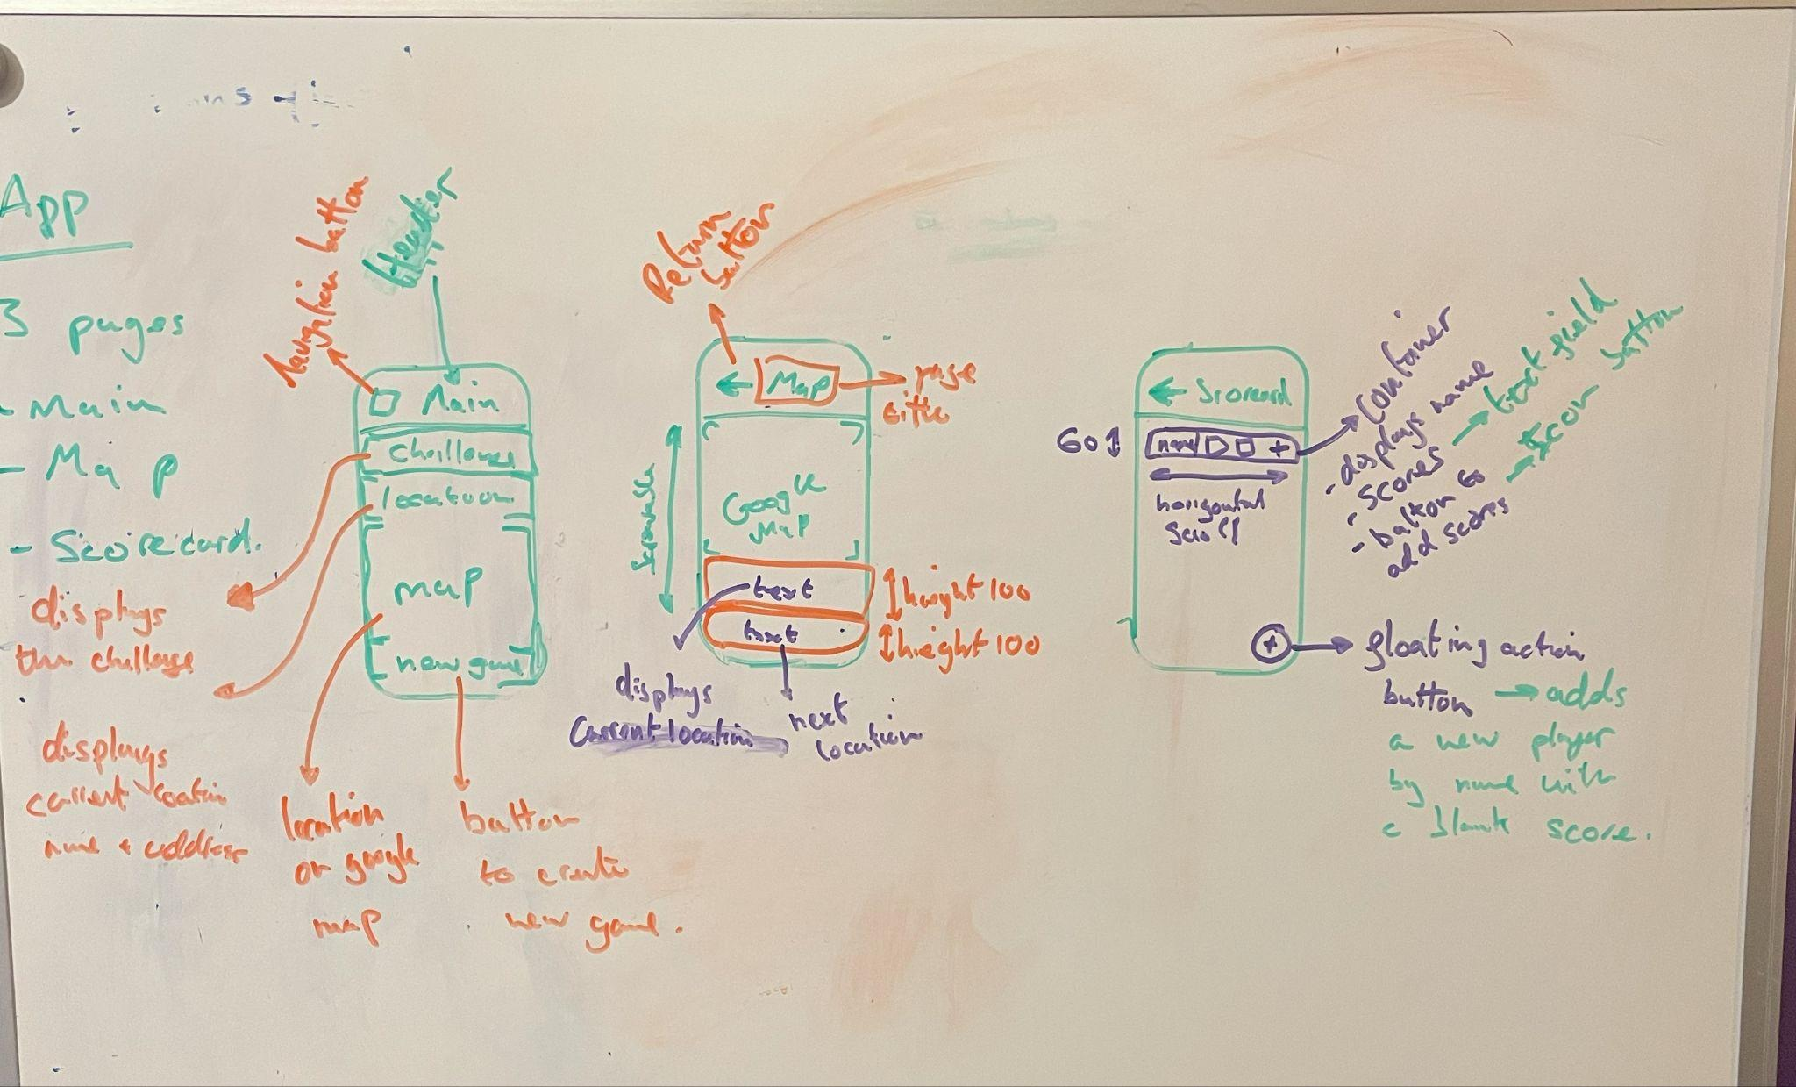

User Interactions:

* Create New Game -> button on main page -> function creates a new game
* Next Challenge -> button in challenge container -> function increments the index
* Next Location -> button in location container -> function increments index
* Previous Location-> button in location container -> function decrements index
* Add a Player -> floating action button -> function adds a new player to the scorecard
* Add score -> icon button in player container -> function adds a new score to the correct player
* Edit score -> text field -> function edits the score at the index
* Remove a player -> button on slidable widget -> removes the player from the game